<Project Name>
project Management plan
Version <1.0>
<mm/dd/yyyy>

VERSION HISTORY
[Provide information on how the development and distribution of the Project Management Plan Template was controlled and tracked. Use the table below to provide the version number, the author implementing the version, the date of the version, the name of the person approving the version, the date that particular version was approved, and a brief description of the reason for creating the revised version.]
Version # | Implemented  By | Revision  Date | Approved  By | Approval  Date | Reason
1.0 | <Author name> | <mm/dd/yy> | <name> | <mm/dd/yy> | <reason>
UP Template Version: 11/30/06
Note to the Author

[This document is a template of a Project Management Plan document for a project. The template includes instructions to the author, boilerplate text, and fields that should be replaced with the values specific to the project.

- Blue italicized text enclosed in square brackets ([text]) provides instructions to the document author, or describes the intent, assumptions and context for content included in this document.

- Blue italicized text enclosed in angle brackets (<text>) indicates a field that should be replaced with information specific to a particular project.

- Text and tables in black are provided as boilerplate examples of wording and formats that may be used or modified as appropriate to a specific project. These are offered only as suggestions to assist in developing project documents; they are not mandatory formats.

When using this template for your project document, it is recommended that you follow these steps:
- Replace all text enclosed in angle brackets (e.g.,, <Project Name>) with the correct field values. These angle brackets appear in both the body of the document and in headers and footers. To customize fields in Microsoft Word (which display a gray background when selected):
  - Select File>Properties>Summary and fill in the Title field with the Document Name and the Subject field with the Project Name.
  - Select File>Properties>Custom and fill in the Last Modified, Status, and Version fields with the appropriate information for this document.
  - After you click OK to close the dialog box, update the fields throughout the document with these values by selecting Edit>Select All (or Ctrl-A) and pressing F9. Or you can update an individual field by clicking on it and pressing F9. This must be done separately for Headers and Footers.
- Modify boilerplate text as appropriate to the specific project.
- To add any new sections to the document, ensure that the appropriate header and body text styles are maintained. Styles used for the Section Headings are Heading 1, Heading 2 and Heading 3. Style used for boilerplate text is Body Text.
- To update the Table of Contents, right-click and select “Update field” and choose the option- “Update entire table”
- Before submission of the first draft of this document, delete this “Notes to the Author” page and all instructions to the author, which appear throughout the document as blue italicized text enclosed in square brackets.]
TABLE OF CONTENTS
1 Introduction – complete week 2 4
1.1 Purpose of Project Management Plan 4
2 Executive Summary of Project Charter – complete week 2 4
2.1 Assumptions/Constraints 4
3 Scope Management- Complete Week 3 4
3.1 Work Breakdown Structure – Start week 3 (continue week 4) 4
3.2 Deployment Plan 5
3.3 Change Control Management 5
4 STAKEHOLDER MANAGEMENT – Complete Week 2 5
5 Cost/Budget Management – COMPLETE WEEK 6 5
6 Quality Management - Complete week 4 5
7 Communications Management – COMPLETE Week 3 5
7.1 Communication Matrix 5
8 Risk Management -COMPLETE WEek 7 6
9 Procurement Management/ HUman resource management -COMPLETE WEEK 5 6
Appendix A: Project Management Plan Approval 7
APPENDIX B: CHARACTERISTICS OF A GOOD PM AND TEAM 8
APPENDIX C: SUMMARY OF SPENDING 9
APPENDIX D: PROJECT METHODOLOGY 10

Introduction – complete week 2

Purpose of Project Management Plan
[Provide the purpose of the project charter.]
The intended audience of the <Project Name> PMP is all project stakeholders including the project sponsor, senior leadership and the project team.

Executive Summary of Project Charter – complete week 2
[Provide an executive summary of the approved IT project. This is the high-level description of the project and why it’s occurring. The description should denote the following items: the description of the project to include, the length of the project, the overall high-level budget, an understanding of why the project is being completed, and any other relevant project information]

Assumptions/Constraints
[An assumption is defined as anything that the project manager assumes to be true about the project such as the software and hardware required for the project will be readily available by the software vendor therefore there will be no delay in obtaining the required hardware or software.
A constraint is defined as something that defines the project. Or what I like to call the guardrails of the project. For example, in a project that is updating the hardware for a kitchen project a constraint of the project is that we are limited to only purchasing hardware for the kitchen (this helps define the project cost as we only have to purchase hardware for the kitchen).]

Scope Management- Complete Week 3
[Insert the project’s scope management plan or provide a reference to where it is stored.]

Work Breakdown Structure – Start week 3 (continue week 4)
[Insert the project’s WBS or use the template below. The students can use MS project and copy and attach the project plan from MS project instead of completing the excel below. Ensure that you are noting the high level task and the sub tasks and denote the task with a number as shown in the example below]

Task | Dependencies | Resources | Start Date | End Date | Notes
This section should contain the number and the task name (1.0 – IT Software 1.1. Base software 1.1.1 the name of the software required) | If there are tasks dependent on this task (meaning this task can’t start until another task is finished enter that here) | Name of resource that will complete this task | Date of task start | Date of task completion | Anything else of interest for this event.

Deployment Plan
[Example: This is a high level statement regarding the plan to deploy the project. This does not have to be extremely detailed.]

Change Control Management
[Denote how change control will occur. Example: is there a change form? Who is responsible for managing the change? Who needs to approve the change? You can create a table if it’s easier to note this or just write a statement on how change will be managed for this project.

STAKEHOLDER MANAGEMENT – Complete Week 2
[Fill out this table and if you’d like to note something about the stakeholder plan, enter that here]
Stakeholder Name | Stakeholder Title | Role on Project | Notes
Place name of stakeholder here | Place title of stakeholder here | Note stakeholders role on project | Anything else of interest or notes?

Cost/Budget Management – COMPLETE WEEK 6
[Insert the project’s cost management plan or provide a reference to where it is stored.]

Quality Management - Complete week 4
[Example: For an information system, controlling the consistency of screen layouts would include reviewing all screens to make sure they match the standards. Quality measures may be no bugs or defects for certain critical requirements, consistent screen layouts, or correctly calculating variables. Quality may be ensured through inspections, audits, formal testing and documentation of defects in a defect tracking system to ensure defects are fixed, retested and closed. Some projects may choose to use a traceability matrix to determine if critical requirements have been met.]

Communications Management – COMPLETE Week 3
[Note the importance of this specific communication plan for this project]

Communication Matrix
[Insert the project’s communication matrix or provide a reference to where it is stored.]
Responsible Party/ Situation | Audience | Vehicles of communication | Frequency | Medium | Feedback Mechanisms/ Notes
Who is responsible for the communication /Describe the situation or deliverable causing the need to communicate. | Who is the audience for this communication | Type of meeting (one on one meetings, team meetings, kickoff meetings, newsletter) | Be specific Mondays @9am (Note when communication will occur) | Examples: presentation, verbal, email, etc… | How should member respond if they have questions and any notes for this task

Risk Management -COMPLETE WEek 7
[Insert the project’s risk management plan or provide a reference to where it is stored.]
Risk | Likelihood | Impact | Mitigation Strategy | Contingency
What is the risk | Likelihood of occurrence (low, medium, high) | If this occurs what is the impact (low, medium, high) | Note what you will do to prevent this risk from occurring | Note what you will do to if this risk occurs and you’ve already completed the mitigation strategy has already been implemented

Procurement Management/ HUman resource management -COMPLETE WEEK 5
[Example: This section should include all of the resources needed for the project. Example: people, tools, machinery, and any other resource that is required for this project should be listed.
In addition, add the procurement management plan. This can include information such as ensuring project team members are assigned computers, how development and test servers are procured or can go into more detail and include an acquisition strategy that details how the project will be staffed (e.g., performance based fixed price contract, CITS contractors).]

Appendix A: Project Management Plan Approval
The undersigned acknowledge they have reviewed the <Project Name> Project Management Plan and agree with the approach it presents. Changes to this Project Management Plan will be coordinated with and approved by the undersigned or their designated representatives.
[List the individuals whose signatures are required for this project. Examples of such individuals are Business Steward, Project Manager or Project Sponsor. Add additional lines for signature as necessary. Although signatures are desired, they are not always required to move forward with the practices outlined within this document.]

Signature: |  | Date:
Print Name:
Title:
Role:

Signature: |  | Date:
Print Name:
Title:
Role:

Signature: |  | Date:
Print Name:
Title:
Role:

APPENDIX B: CHARACTERISTICS OF A GOOD PM AND TEAM
[Include the characteristics of a good project manager and a good team in this section.)

APPENDIX C: SUMMARY OF SPENDING
[You may double-click on the table to edit it according to the information applicable to this project.]
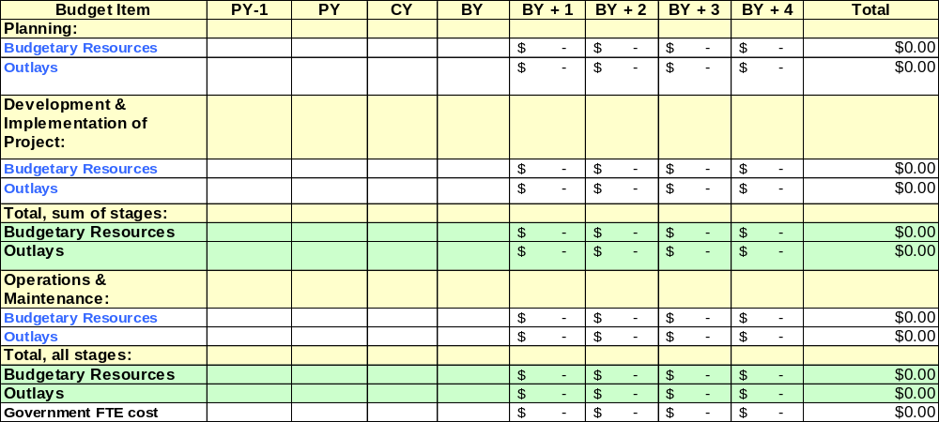PY: Previous Year; CY: Current Year; BY: Budget Year

APPENDIX D: PROJECT METHODOLOGY
[This is based on the specific project methodology that was selected in week 2. Note differences in this project plan versus what would be included in the specific project method selected. Please note: what’s left out, what’s extra, if you’ve modified this template how and why based on the methodology selected, and anything else of interest.]

